WEEK 1
TOPIC: Programming Language
CONTENT

PROGRAMMING LANGUAGE
A vocabulary and set of grammatical rules for instructing a computer to perform specific tasks. The term programming language usually refers to high-level languages, such as
BASIC ,
C ,
C++ ,
COBOL,
FORTRAN,
Ada , and
Pascal.
Each language has a unique set of keywords (words that it understands) and a special syntax for organizing program instructions .
High-level programming languages, while simple compared to human languages, are more complex than the languages the computer actually understands, called machine languages .
Each different type of CPU has its own unique machine language.

MACHINE LANGUAGE
Programming language that can be directly understood and obeyed by a machine (computer) without conversion (translation). Different for each type of CPU, it is the native binary language (comprised of only two characters: 0 and 1) of the computer and is difficult to be read and understood by humans.

LOW LEVEL LANGUAGE
In computer science , a low-level programming language is a programming language that provides little or no abstraction from a computer's instruction set architecture commands or functions in the language map closely to processor instructions. Generally this refers to either machine code or assembly language .

HIGH LEVEL LANGUAGE
A programming language such as C , FORTRAN, or Pascal that enables a programmer to write programs that are more or less independent of a particular type of computer. Such languages are considered high-level because they are closer to human languages and further
from machine languages.

Questions
- What is a programming language ?
- Gives examples of a programming Language

Assignments
Define the following
- Machine Language
- Low level language
- High level language

WEEK 2
TOPIC: BASIC programming language
CONTENT
ELEMENTS OF QBASIC

INTRODUCTION
Every programming language consists of some basic elements which are required to make a program. The element required to construct a BASIC program consists of a set of characters, keywords, constants, variables, operators and expressions.

1. CHARACTER SET
The BASIC Character Set consists of alphabets (both small and capital), numbers (0 to 9) and special characters. These special characters have their own meaning and function.

2. KEYWORD
Keywords are those words which have special meanings in BASIC. Keywords are statements or Reserved Words, commands, and names of operators. Some reserved words are CLS, REM, INPUT, LET, PRINT, FOR, DO, SELECT, MID$, ASC, SQR, LEN, LEFT$, TIME$ and INT.

3. CONSTANTS
Constants are the data or the values in a program that cannot be changed during the program execution. The data may be a letter, words, numbers, or special characters. Types of constant are

a. Sting Constant
b. Numeric Constant

4. VARIABLE
A variable is an entity that stores data needed to be used in a program. Each program defines different number of variables.
There are mainly two types of variables. They are:
i. String Variable
ii. Numeric Variable

5. OPERATOR
Operators are symbols that indicate the type of operation BASIC has to perform on the data

There are four types of operators in BASIC. They are Arithmetic Operators, Relational Operators, Logical Operators and Sting Operator.

QBasic’s Math Operators

OBJECTIVES:
- Using QBasic Math Operators
- Use Order of Operation
- Store the results of calculations in variables
- Print the result of calculations

A Math Operator is a symbol use for addition, subtraction, multiplication, division, or other calculations

The QBasic math operators and their meanings.
Symbol | Meaning
* | Multiplication
/ | Division
+ | Addition
- | Subtraction
^ | Exponentiation
\ | Integer division
MOD | Modulus

Example: (95/2=47.5)
Formula | Results
8\2 | 4
95\2 | 47
95.0\2 | 47
95\2.0 | 47
95.0\2.0 | 47

WEEK 3
TOPIC: Examples of BASIC PL
CONTENT
Q-BASIC PROGRAMS

1)Write a program to enter your name and print it .

CLS
Input 'Enter you name';n$
Print 'The name is';n$
End

2)Write a program to enter your name, city, country, age and print them.

CLS
Input " Enter the name ";N$
Input " Enter the city";C$
Input " Enter the country";CO$
Input " Enter the age";A
Print " The name is ";N$
Print " The city is ";C$
Print " The country is ";CO$
Print " The age is ";A
End

3)Write a program to find the area of rectangle.

Cls
Input " enter the length " ;l
Input " enter the breadth " ;b
let A = l*b
Print" the area of rectangle=" ;a
End

4)Write a program to find the area of the triangle.

Cls
Input " enter the base" ;b
Input " enter the height" ;h
let T = 1/2*b*h
Print" The area of triangle=" ;T
End

5)Write a program to find the area of the circle.

Cls
Input" Enter the radius " ;R
Let C=22/7*R^2
Print " The area of circle =" ;C
End

6)Write a program to find the circumference of the circle.

Cls
Input" Enter the radius " ;R
Let Circumference=22/7*R*2
Print " The area of circle =" ;Circumference
End

7)Write a program to find the area of the square.

Cls
Input" Enter the number" ;n
Let square= n^2
Print" The area of square=" ;Square
End

8)Write a program to find the area of the square and cube.

Cls
Input" Enter the number" ;n
Let square= n^2
Let Cube = n^3
Print" The area of square=" ;Square
Print" The area of cube=" ; Cube
End

WEEK 4
TOPIC: Graphic Packages
CONTENT
GRAPHICS PACKAGES
A graphics package is an application that can be used to create and manipulate images on a computer.
There are two main types of graphics package:
- painting packages
- drawing packages
Painting packages
- A painting package is a graphic application that can be used for processing photographs by manipulating features like colors, effects, brightness, etc
- A painting package produces images by changing the colour of pixels on the screen.
Advantages
- The main advantage offered by this type of graphic is that it can be used for adjusting and beautifying photographs

- Disadvantages of painting packages
- Individual parts of an image cannot be resized;
- only the whole picture can be increased or decreased in size.
Examples of graphics packages that produce bitmapped images include:- MS Paint, PC Paintbrush, Adobe Photoshop and JASC’s Paint Shop Pro.
Drawing packages
- A drawing package produces images that are made up from coloured lines and shapes such as circles, squares and rectangles.
- When an image is saved it is stored in a vector graphics file as a series of instructions, which can be used to recreate it.
Main advantages of vector graphics are:
- They use less storage space than bitmap graphics;
- Each part of an image is treated as a separate object, which means that individual parts can be easily modified.
Disadvantages of drawing packages
- They don’t look as realistic as bitmap graphics.
Examples of drawing graphics packages include CorelDraw, Micrographix Designer and computer aided design (CAD) packages such as AutoCAD.

Common features of graphics packages
- Drawing straight lines and ‘freehand’ lines;
- Drawing regular pre-defined shapes like squares, rectangles and circles using a special ‘tool’;
- Entering text and changing the style and size of font;
- Changing the size of an object, or scaling;
- Rotating objects in either clockwise or anticlockwise by specifying the direction and angle of rotation;
- Stretching objects either horizontally or vertically. ‘Flipping’ an object either horizontally or vertically.
- A paint palette from which different colours and patterns can be chosen.
- A fill option for colouring in a shape or area on the screen with a colour or pattern from the paint palette.
- Most graphics packages have a built-in library of clipart pictures.
- Zoom or magnify is a feature that allows an area of the screen to be seen close up for detailed work.
- Special brushes such as an airbrush can be used to achieve different paint effects on the screen.
- In most graphics these features are chosen from a toolbar or tool palette where they are displayed as icons.
Questions
- Define Graphic Package ?
- Mention the two types Graphic Package

Assignment
- Explain the Painting Package
- Explain the drawing Package

WEEK 5
TOPIC: features of the graphics Packages
CONTENT

Title bar
The title bar is a bar located at the top of a window or a dialog box that displays the name of the window or software program being used. For example, in the picture below, the title bar displays the name of the program

Toolbar
Sometimes referred to as a bar, the toolbar is a row of boxes, often at the top of an application window that control various functions of the software. The boxes often contain images that correspond with the function they control, as demonstrated in the image below

Menu bar
A thin, rectangular window containing dropdown menus, a menu bar is used in many computer programs. Its primary function is to house application or window-specific menus that provide an assortment of functions to the user. These functions include interactions like opening files, editing text, bringing up software-related help menus.
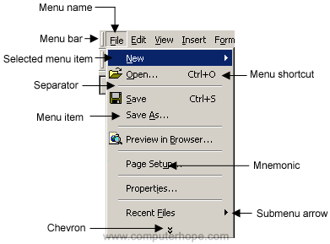

Colour palette

This comprises of different colours for your drawing. The colour can be selected by clicking on them.

Printable Area

this is portion where our drawing and pictures are maniputed and placed for printing.

PRACTICAL

WEEK 5
TOPIC: Graphic Packages-Paint tools

FEATURES OF THE GRAPHIC PACKAGE - PAINT

Paint tools

Applies to Windows Vista
Paint is a program you can use to create drawings on a blank canvas or on top of other pictures. The program features a toolbar on the left side of the window. The following tables describe how to use each of the tools on this toolbar.

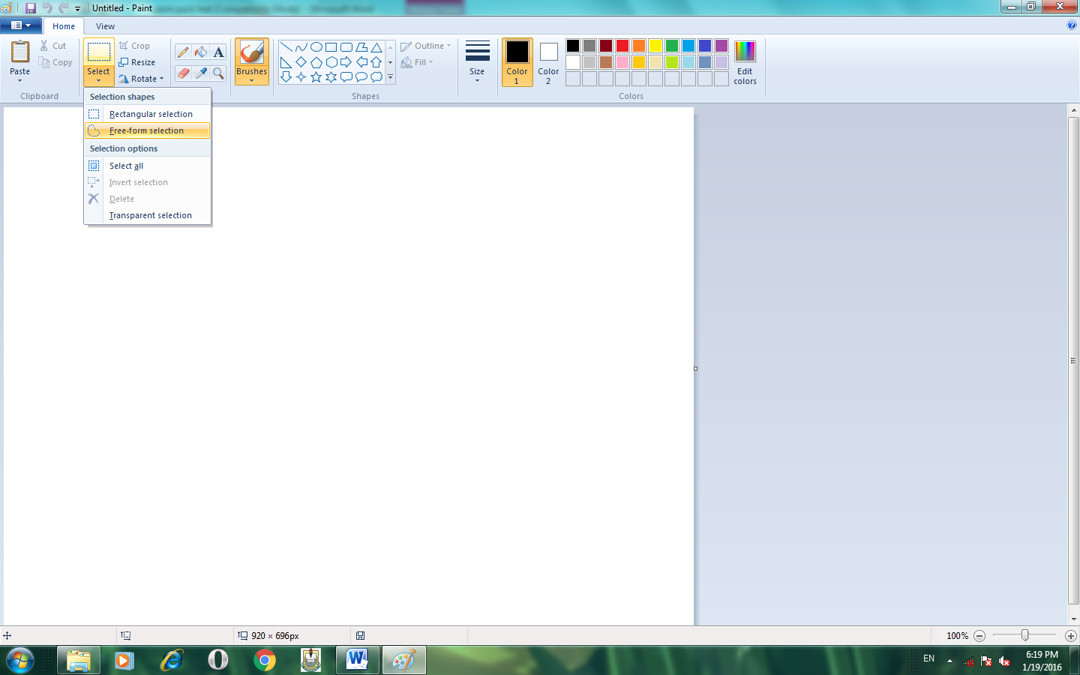
Tool

Description
Use Free-Form Select to select any irregularly shaped part of the picture

Tool

Description
Use Select to select any square or rectangular part of the picture.

Tool

Description
Use the Eraser to erase areas of your picture.

Tool

Description
Use Fill With Color to fill the entire picture or an enclosed shape with color.

Tool

Description
Use Pick Color to set the current foreground or background color.

Tool

Description
Use the Magnifier to zoom in on a section of your picture.

Tool

Description
Use the Pencil to draw thin, freeform lines or curves.

Tool

Description
Use the Brush to paint thick or shaped freeform lines and curves.
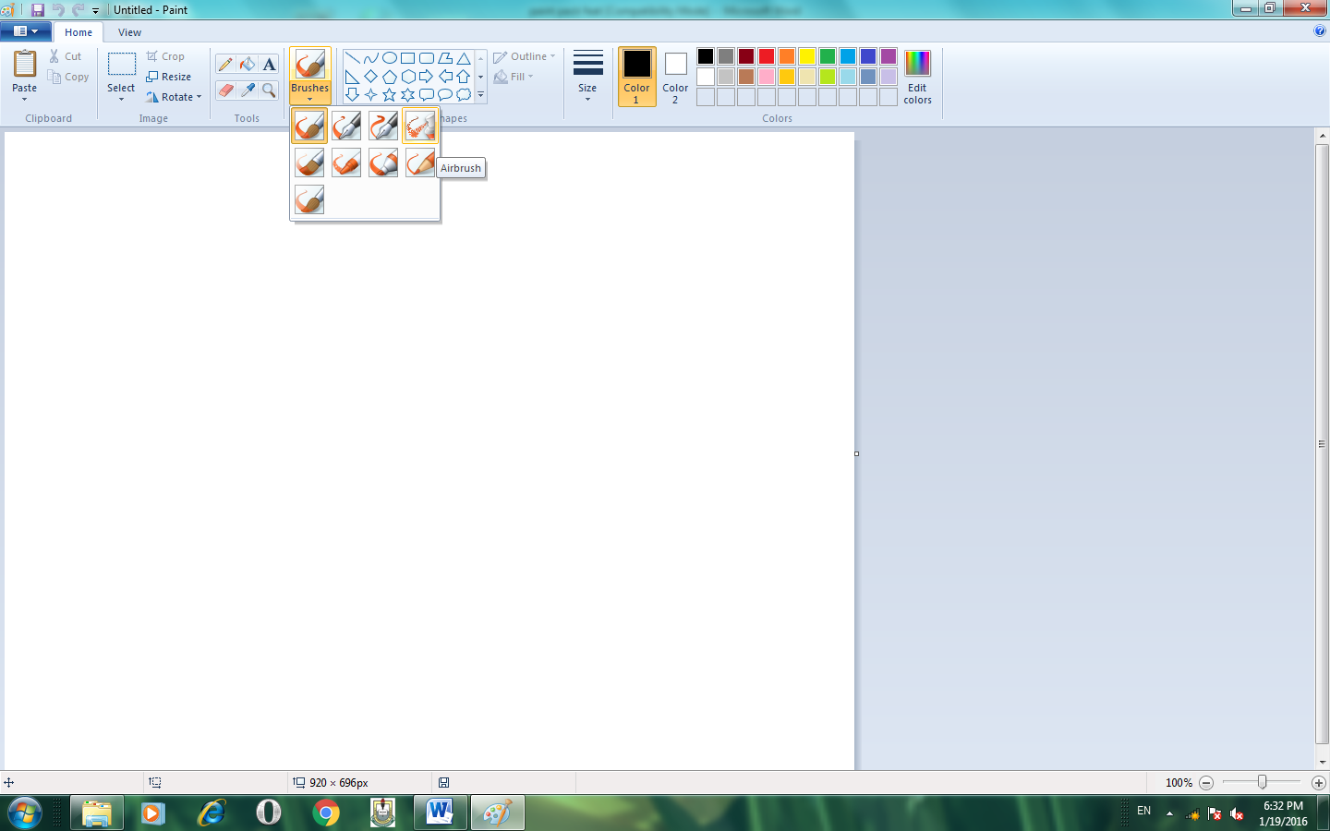
Tool

Description
Use the Airbrush to create an airbrush effect in the picture.

Tool

Description
Use Text to enter text in the picture.

Tool

Description
Use Line to draw a straight line.

Tool

Description
Use Curve to draw a smooth, curved line.

Tool

Description
Use Rectangle to draw rectangular shapes.

Tool

Description
Use Polygon to make a shape with any number of sides.

Tool

Description
Use Ellipse to make ellipses and circles.

Tool

Description
Use triangle to draw triangular shapes.

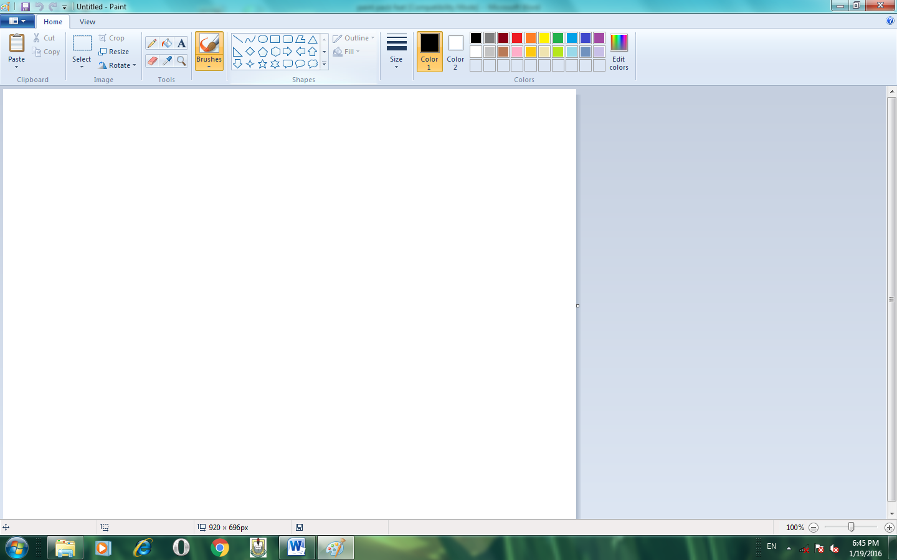

Tool

Description
The Color box indicates the current foreground and background colors.

Tool

Description
Choose the desired line thickness when you draw lines and curves.
Option

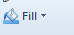

Description
Choose the desired fill effect when you draw shapes.

PRACTICAL

WEEK 7-8
TOPIC: Information and Communication Technology
Information and Communications Technology (ICT)

Definition - What does Information and Communications Technology (ICT) mean?

Information and communications technology (ICT) refers to all the technology used to handle telecommunications, broadcast media, intelligent building management systems, audiovisual processing and transmission systems, and network-based control and monitoring functions.

Examples of ICT gadgets
Computers
Telephones
Cellular network
Satellite communications
Television
Internet

Benefits of ICT

Some of the benefits of ICT are
- Access to information and research are cheaper and timely
- ICT increase the speed of transactions and processing
- It helps in creating interactions among people
- With ICT , distances in business transactions and learning is never a barrier
- It provides employment opportunities to people globally
- it brings efficiency in many areas such as e-learning, e-commerce, E-administation etc
- It is useful in medical and scientific industries.

Disadvantages of ICT

- It can lead to job losses as a result of computerized transactions in offices
- ICT threatens other areas and fields of human Endeavour.
- Virus are contacted through the internet and could damage files in the computer systems
- Some seawares can be difficult for people to use
- People are almost completely relying on computer which becomes nearly impossible to do much without computer.
- Repetitive strain injure, strain on tendon of the arms, back problems and painful eyes are caused from prolong use of the computer.
- Youth often abuse the internet by using it mostly entertainment, watching pornographic shows, and using it to commit crime.
- Ict use can lead to computer addiction ,obsessive computing behaviuor and stress
- People prefer to send emails or call their friends on phones rather than visit them.

Quesiotns
      - Define the ICT
      - State the ICT gadgets

Assignment
States the Benefits and Disadvantages of ICT

WEEK 9
TOPIC: ICT Gadgets – the GSM
ICT Gadgets: - The GSM

The GSM (Global System for Mobile Communications) is a second- generation digital mobile telephone standard using a variation of Time Division Multiple Access (TDMA). It is a mobile telephone using a wireless technology that allow users to communicate with people that are not within their reach.
It is the most widely used of the three digital wireless telephone technologies - CDMA (Code Division Multiple Access), GSM and TDMA.
It operates at either the 900, 1800 or 1,900MHz frequency bands.

TECHNICAL DETAILS
The GSM network can be divided into three broad parts
The subscriber carries the mobile station
The base station subsystem controls the radio link with the
mobile station
The network subsystem performs the switching of calls
between the mobile users and other mobile and fixed
network users

Questions
- State the full meaning of GSM
- State how to send messages of GSM

WEEK 10
TOPIC: ICT Gadget- fax and telephone
FAX
Fax (short for facsimile), sometimes called telecopying or telefax , is the telephonic transmission of scanned printed material (both text and images), normally to a telephone number connected to a printer or other output device. The original document is scanned with a fax machine (or a telecopier), which processes the contents (text or images) as a single fixed graphic image, converting it into a bitmap, and then transmitting it through the telephone system in the form of audio-frequency tones. The receiving fax machine interprets the tones and reconstructs the image, printing a paper copy.
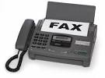

TELEPHONE
Telephone, or phone, is a telecommunications device that permits two or more users to conduct a conversation when they are too far apart to be heard directly. A telephone converts sound, typically and most efficiently the human voice, into electronic signals suitable for transmission via cables or other transmission media over long distances, and replays such signals simultaneously in audible form to its user.

